**DAILY ONLINE ACTIVITIES SUMMARY**

|  |  |  |  |  |  |  |  |  |
| --- | --- | --- | --- | --- | --- | --- | --- | --- |
| **Date:** | **30-6-2020** | | | | | **Name:** | **Poojashree T** | |
| **Sem & Sec** | **8th sem B sec** | | | | | **USN:** | **4al16cs064** | |
| **Online Test Summary** | | | | | | | | |
| **Subject** | | **No Test** | | | | | | |
| **Max. Marks** | |  | | **Score** | | |  | |
| **Certification Course Summary** | | | | | | | | |
| **Course** | **Introduction to R language tutorial** | | | | | | | |
| **Certificate Provider** | | | **Great learning academy** | | **Duration** | | | **3.0hr** |
| **Coding Challenges** | | | | | | | | |
| **Problem Statement:** **1**. **to read the number and compute the series.**  **2. to count the number in th series.**  **3. to check whether number is palindrome or not.**  **4. to find the number between 0 and 50 which are not divisible by 2 and 3.**  **5.micro and array update**  Top of Form | | | | | | | | |
| **Status:completed** | | | | | | | | |
| **Uploaded the report in Github** | | | | | **yes** | | | |
| **If yes Repository name** | | | | | **Poojatgowda** | | | |
| **Uploaded the report in slack** | | | | | **yes** | | | |

**Online test**

No Test

**Certification course**

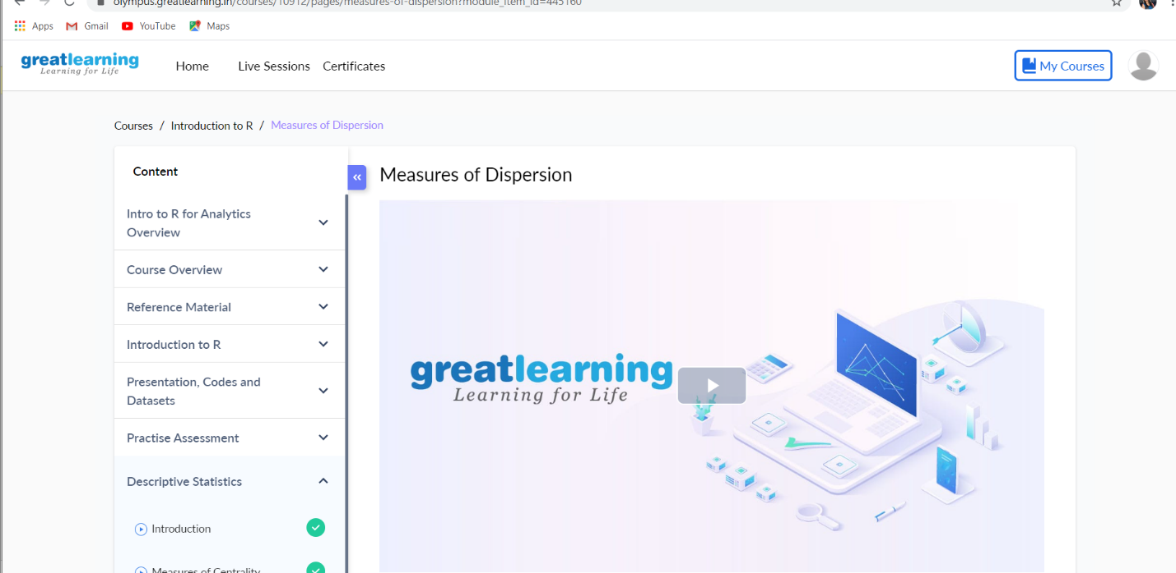

**Program to display the prime numbers from 1 to 100**

It will display the prime numbers between 1 and 100.

class PrimeNumbers

{

public static void main (String[] args)

{

int i =0;

int num =0;

//Empty String

String primeNumbers = "";

for (i = 1; i <= 100; i++)

{

int counter=0;

for(num =i; num>=1; num--)

{

if(i%num==0)

{

counter = counter + 1;

}

}

if (counter ==2)

{

//Appended the Prime number to the String

primeNumbers = primeNumbers + i + " ";

}

}

System.out.println("Prime numbers from 1 to 100 are :");

System.out.println(primeNumbers);

}

}

Output:

Prime numbers from 1 to 100 are :

2 3 5 7 11 13 17 19 23 29 31 37 41 43 47 53 59 61 67 71 73 79 83 89 97